Hawthorn Parish Council
Clerk to the Council: Lesley Swinbank MBA, FSLCC
Springwell House, Spring Lane, Sedgefield Co. Durham. TS21 2HS
Tel. 01740 622429
Email: clerk@hawthornparish.co.uk

You are summonsed to attend the Monthly Meeting of the Hawthorn Parish Council which will be held on Monday 15th May 2023 following on immediately from the Annual Meeting of the Council, in the Community Centre.

AGENDA

Notice of Meeting
Public Notice of the Meeting has been given in accordance with Sch 12 paragraph 10(2) of the LGA 1972

Apologies: To receive apologies and to approve reasons for absence

Declarations of Interest
To notify of any items that appear in the agenda in which you may have an interest, including those that have previously been recorded in the Members Register of Interests.

Neighbourhood Watch: Mrs. Jayne Littlewood

Minutes:

To approve the Minutes of the Monthly Meeting held Monday 17th April 2023

Matters of Information: As per attached information sheet

Reports

Police

DCC

Community Centre

Play Area

Any other reports

Public Participation: Comments on items on this agenda

Correspondence

Response re attack on a dog

CDALC As attached

Letter re re-cycling

Infn re footpath temporary diversion / closure

Financial:

To endorse the monies paid by the Clerk since the last meeting / Bank reconciliation.

Changing bank accounts

Insurance Premium

Training:

Planning: Current Planning applications

Neighbourhood watch Scheme

Events & Information

Coronation Community Event

Date of the next meeting: Monthly Meeting of the Council: Monday 26th June 2023
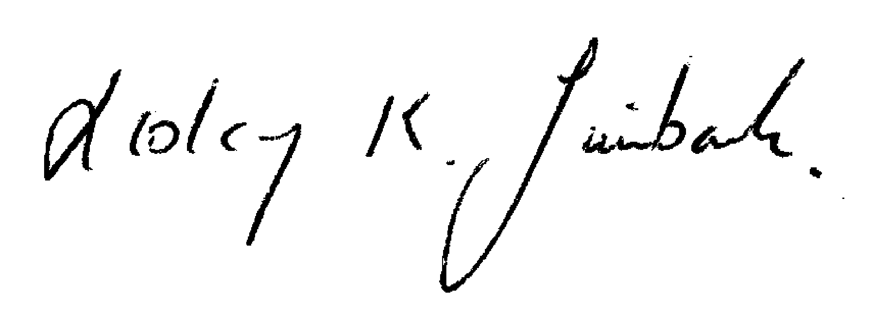

Lesley K. Swinbank (Parish Clerk):
8th May 2023

All residents and the press are welcome to come along to the meeting.

