Hawthorn Parish Council
Clerk to the Council: Lesley Swinbank MBA, FSLCC
Springwell House, Spring Lane, Sedgefield Co. Durham. TS21 2HS
Tel. 01740 622429
Email: clerk@hawthornparish.co.uk

In accordance with Paragraphs 8 & 10(2) (b) of Schedule 12 of the Local Government Act 1972, I hereby summon you to attend a Meeting of HAWTHORN PARISH COUNCIL to be held in the COMMUNITY CENTRE HAWTHORN on MONDAY 18th SEPTEMBER 2023 at 7pm

AGENDA

Notice of Meeting
Public Notice of the Meeting has been given in accordance with Sch 12 paragraph 10(2) of the LGA 1972

Apologies: To receive apologies and to approve reasons for absence

Declarations of Interest
To notify of any items that appear in the agenda in which you may have an interest, including those that have previously been recorded in the Members Register of Interests.

Minutes:

To approve the Minutes of the Monthly Meeting held Monday 17th July 2023

Matters of Information : As per sheet circulated to members

Reports

Police

DCC

Community Centre

Small Councils Committee (Report circulated to members)

Play area report

Any other reports

Public Participation: Comments on items on this agenda

Correspondence

Hawthorn – Flooding

Petition and associated information re B1432

Financial:

To endorse the monies paid by the Clerk since the last meeting / Bank reconciliation.

½ Year Accounts / Estimates

Grant application from the Community Centre

Trees on Village Green : Quote

Changing bank accounts : Progress report

Draft Climate Change Information

Training:

Planning: Current Planning applications

Neighbourhood Watch Scheme : Update on information

Events & Information

Switching on lights : Dec 2nd

Hard copy newsletter

Dates of the next meeting:s Monthly Meeting of the Council: Monday 16th October / November 2023
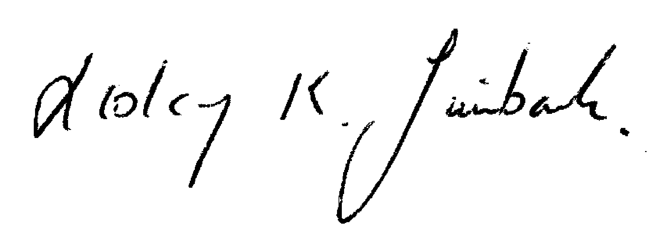

Lesley K. Swinbank (Parish Clerk): 10th September 2023
All residents and the press are welcome to come along to the meeting.

