The December Monthly Meeting of the Hawthorn Parish Council was held at 7pm on Monday 11th December 2023, in the Community Centre.

MINUTES

Present
Cllr Diane Hughes (Chairman)
Cllr. Sheila Irving (Vice – Chairman)
Cllrs. Alan Askew, Maxine Smith, Gary Thompson, Sheila Wilson, Carolyn Winter

DCC Cllr. Angela Surtees

Officer: Lesley Swinbank (Parish Clerk)

Members of the Public: 1

Notice of Meeting
Public Notice of the Meeting has been given in accordance with Sch 12 paragraph 10(2) of the LGA 1972

Apologies
PCSO Carole Huitson

Declarations of Interest
Cllr. Maxine Smith: Item 11

Minutes:

RESOLVED

To approve the Minutes of the Monthly Meeting held Monday 13th November 2023

Matters of Information
No new information.
RESOLVED
To contact Believe once again and ask if there is any progress on the repairs to the fence at Glencot Grove.

Reports

Police
PCSO Carole Huitson had e mailed her report.
03/12/23
Report of vehicle driving recklessly and at speed almost causing an accident on Stockton Road heading towards Easington.

04/12/2023
Report of West Lane being Flooded

07/12/2023
Report of a male pretending to be from ‘recovery for soldiers’ charity at Western Park, Hawthorn, it was reported that the male had no ID and had become angry and intimidating when caller tried to close the door. No trace of male when officers attended
RESOLVED
To receive the information

DCC
The Chair, Cllr. Diane Hughes welcomed DCC Cllr. Angela Surtees to the meeting.
Cllr. Surtees reported on the following: -
- Flooding at North End of Village
DCC are aware of the ongoing flooding issues are looking to address the problems with the overall drainage system as well as excess water from the adjacent fields.

- New signage : B1432
The new road signs are now in place, although there are a couple of issues – in particular one sign being covered by tree branch.
Cllr. Surtees to report this back to DCC

- Replacement Bus Shelter : B1432
Cllr. Surtees said she had been contacted by a resident of the village re ensuring the replacement shelter is like for like as the old shelter – i.e. built using bricks.

- Boundary Commission : New recommendations
The new Cllr. Ward nos and boundaries have now been published.
These will have a direct influence on the DCC Cllrs for Hawthorn.

Cllr. Surtees was thanked for attending the meeting and giving her report.

Community Centre
The Chair Cllr. Diane Hughes gave the report which included information on the forthcoming pantomime.
RESOLVED
To receive the information.

Smaller Council Meeting
The report from Cllr. Diane Hughes, Chair, had been circulated.
This included details of: -
- Community Resilience and Community Emergency Plans: Presentation from Emily Hunter
- CDALC subscription fees to rise by 2p per elector.
- Graham Morris has resigned as President.
- Durham is a pilot area for the anti-social behaviour plan.
- LCTRS Grant. (Local Council Tax Reduction Scheme) Agreement that this will now be over 3 years instead of 2.
- Update on Parliament decision on holding remote meetings. Parliament has said this is not allowed.

Any other reports
East Durham Councils
Cllr. Diane Hughes gave the report – although the meeting was not quorate.

RESOLVED
To receive the reports

Public Participation
A member of the public expressed concerns about the ongoing problems with flooding at the north end of the village.

Correspondence

Dogs barking and off lead.
A local resident has expressed concerns about the nuisance of dogs being left outside of their owners’ properties each day and excessive barking.

In addition, there appears to be a number of residents not having their dogs on a leash when out walking.
The Clerk said she has responded to the resident and also included the legal situation on both issues within the Round Up, i.e. statutory noise nuisance can be reported to DCC and not have a dog on a lead in public places should be reported to the Police.

RESOLVED
To receive the information.

Royal Garden Party
Information re nominating a Cllr. To attend a Royal Garden Party has been received from CDALC.
RESOLVED
To take no action at this time.

Financial:

RESOLVED

To endorse the monies paid by the Clerk since the last meeting.

11/12/2023 | Horns | Christmas Tree | £180.00
11/12/2023 | Hawthorn Trees | Pruning village green | £350.00
11/12/2023 | Glosticks | Presents | £139.91
11/12/2023 | SLCC | Subs | £161.00
11/12/2023 | Sainsbury | Switch on Lights | £57.50
12/12/2023 | Community Centre | Rent for year | £220.00
12/12/2023 | LKSwinbank | Repayment | £500.00

Changing bank accounts
The Clerk informed members that the new Unity Bank account is now up and running. However, there is a delay in depositing the £14,000 cheque from Barclays as a paying in slip needs to be printed, and whilst the Clerk has been advised to post the cheque to Unity, the Clerk feels that it will be better to wait until after Christmas in case the cheque is lost in the post, or to take it through to a Nat West branch.
As a result of this delay and in order to get the account up and running the Clerk has personally transferred £500 from her own personal account – and which will be repaid as soon as possible.
RESOLVED
To receive the information and to thank the Clerk for taking this action.

To approve the national pay award 2023 /2024
The information regarding the agreed pay rise had been circulated. This amounts to £1925 pro rata.
RESOLVED
To implement the pay award from 1st April 2023.

Precept 2024 / 2025
Information from DCC had been circulated.
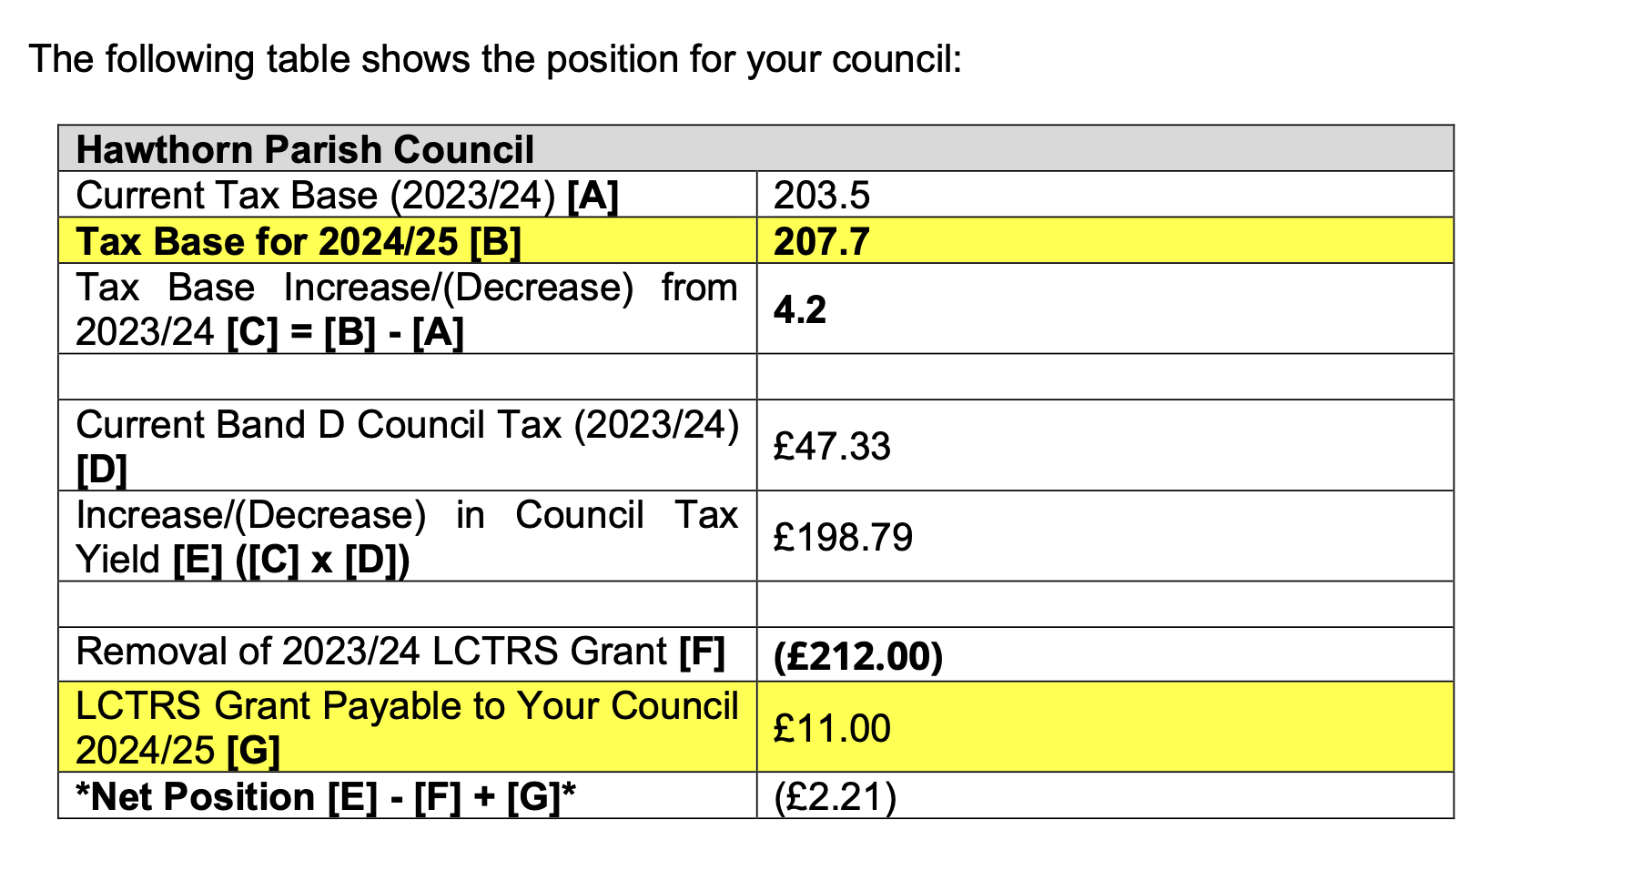
After discussion and consideration of the information as shown below - it was agreed to set the precept at £10,700 for 2024 / 2025 – representing an 8.82% increase.
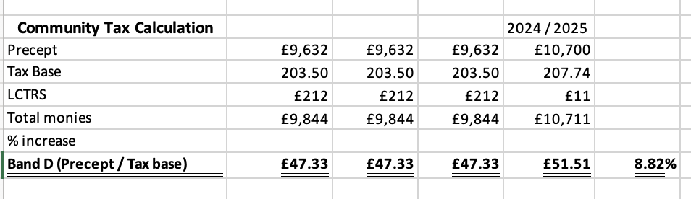

This to be formally approved at the January meeting.

Training:
None to date

Overhead electricity cables / damage
Cllr. Maxine Smith had declared an interest – but as this is not the responsibility of the Parish Council – Cllr. Smith was able to give a brief outline of recent damage caused by the overhead cable falling on cars parked beneath.
RESOLVED
To receive the information.

Planning: Current Planning applications
No new applications have been received.

Events & Information

Switching on lights: Dec 2nd
The Chair said the event had been very successful and thanked all who helped and attended.
The Clerk said she had written to Santa thanking him.
Some concerns were expressed regarding the height of the Christmas Tree and problems attaching the lights etc.
RESOLVED
- To purchase a smaller tree next year
- To hold the switching on event next year on Sunday December 1st
- To book Rebecca Smith for the entertainment

Dates of the next meetings:

Monthly Meeting of the Council: Monday 15th January 2024
- Next meetings for publication
Feb Monthly Meeting Feb 26th
Annual Parish Meeting March 18th
March Monthly Meeting March 18th
April Monthly Meeting April 15th
Annual Meeting May 20th

The Chairman thanked everyone for attending and closed the meeting at 8.30 pm.

