Hawthorn Parish Council: Information Nov 2020
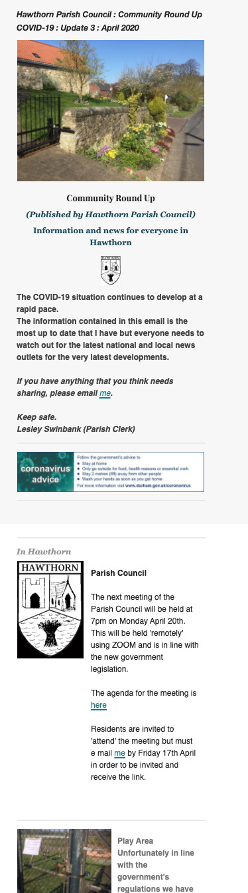
This is a brief outline of how the Parish Council are managing the current situation.

- Meetings of the Parish Council
These continue to be held ‘remotely’ using ZOOM in line with Government Legislation and Advice. The agendas will continue to be posted on the noticeboards. Residents are able to join the meeting via computer, tablet or iphone. The Zoom link is shown on each agenda, the website and in the Hawthorn Community Round Up. Or can e mail tme clerk@hawthornparish.co.uk at least 1 days beforehand in order to request the invitation link. Residents are able to participate during ‘Public Participation’.
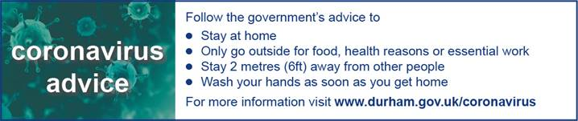
- Council Events and Information
Over recent months most of the Council’s events with the exception of the Sunflower Competition together with the summer newsletter have been cancelled. However we will continue to have our Christmas Tree and ‘Switching On’ will take place albeit on a much smaller scale this year together with the Annual Snowman and new ‘Best Christmas Decorated House’ competitions.

- Council Jottings : Parish Council have recently discussed
- Problems of cars being parked around the village green onto West Lane. This is resulting in buggies / wheelchairs having to use the road to get past the vehicles which is dangerous. Please don’t park in this way.
- Ploughed up Right of Way footpath near the Rectory. This has been reported to DCC who are taking action.
- Vermin – Concerns have been expressed re the increase in rats / vermin attracted by leaving crusts/ leftovers – usually on the ground and usually overnight.
- Planning for the Future – the Council has responded to the White Paper which is looking to centralise planning decisions.

The monthly Hawthorn Community Round Up continues to be our primary method of communication with you. E mail clerk@hawthornparish.co.uk to sign up.
Hawthorn Parish Council: Information Nov 2020

