Hawthorn Parish Council

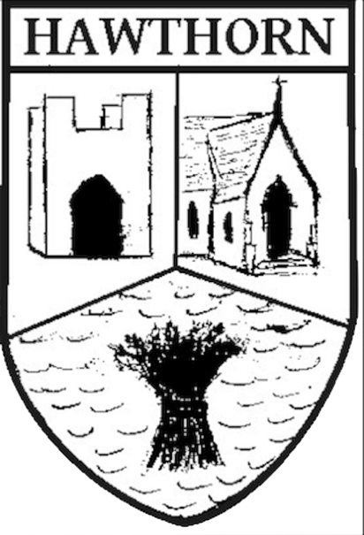

POLICY
Use of
Noticeboards

Approved July 2022

Hawthorn Parish Council

POLICY: Use of Noticeboards

Introduction
- This policy describes the proper use and maintenance of Hawthorn Parish Council noticeboards as approved July 2022.
- The purpose of the policy is to provide guidelines for usage of community notice boards and the material which can be displayed.
- The objective of the policy is to facilitate the provision of community information of interest to the residents and visitors of the Parish of Hawthorn.

Background
Parish Councils are required to maintain a noticeboard for statutory notices to be published and other notices to be displayed. Hawthorn Parish Council has provided and maintained two noticeboards in the village over many years.
These have been replaced by 2 new solar powered noticeboards and a lectern type notice board – all purchased courtesy of a grant from Awards 4 All.

Location of Parish Noticeboards
The two solar powered noticeboards are located: -
- On the village Green adjacent to the wall and Community Centre
- On the area of grass at the junction of Stockton Road and High West Lane
The lectern type board is on the village green opposite the Stapylton Arms.

In addition, there is a ‘virtual’ noticeboard on the Parish Council website at www.hawthornparish.co.uk

Use of the Parish noticeboards
The primary purpose of the noticeboards is to disseminate public information, and priority will always be given to Parish Council notices.

Solar powered Boards
The two solar powered noticeboards may be used for official notices, statutory notices, and community information notices.

Official notices
Statutory / Official notices include but are not limited to.
- Parish Council agendas
- Election notices and results
- Statutory notices relating to the annual audit.
- Notices advertising the Annual Parish Meeting
- Notices advertising Parish Council Meeting dates
- Contact details of Parish Clerk / Cllrs

Community information notices
Community information notices include but are not limited to
- Parish Council Newsletters / Round Up
- Notices advertising Parish Council events
- Notices / information from and the Community Centre Association
- Notices / Information from other Hawthorn Organisations
- Notices / information from organisations outside the parish but being of interest to residents.

Use of the lectern notice board
This is limited to more ‘permanent’ information of use to hawthorn residents and visitors.
This includes – but is not limited to: -
- Map of Hawthorn Rights of way
- Calendar of Community Events
- General information about the village.
- Displays / photos of particular events – e.g., the Jubilee Celebrations.

Information / notices which will not be allowed
The following are not to be displayed on the noticeboards
- Commercial advertisements.
- Publicity for any fundraising event or organisation that is not a charity.
- Political notices

Requirements to be met
- The notice must include clear details of the organisation or person posting the notice – and if necessary, any contact details. HPC are not responsible for passing on any information / questions / comments.
- Notices should be factually correct and must not be critical or offensive to any person or organisation.

Authority to use the Noticeboard
- The Parish Council has appointed Cllr. Sheila Irving who has the authority to display notices on the noticeboards.
- Cllr. Irving is the only person holding the keys to the Noticeboards
- Community information notices will be displayed provided space is available however Official Notices will always take precedence.
- Councillors can also advise on suitability of notices and receive material for publication from residents where necessary – these will be forwarded to Councillor Irving.
- Material should ideally be sent to Councillor Irving as a Hard Copy, or e mailed to her at Sheila.irving@hawthornparish.co.uk

Timescales
Notices /posters can be displayed up to 8 weeks before the event takes place , and will be posted within 7 days of being received by Cllr. Irving.

Display of material on Parish Council website.
In addition to physical noticeboards the Parish Council has a website which is also used to display Parish Council agendas minutes and meeting dates. In addition, the website contains details of Financial Regulations, Code of Conduct, other policies, and links to other Websites.
Material for posting on the Parish Council website should be sent in electronic format to the clerk in the first instance but is subject to a separate policy.

Fly posting
No material is to be displayed on the physical noticeboards and Unauthorised notices or notices which are fly posted on public property around the Parish e.g., lampposts will be subject to removal by the council.

Maintenance

The Parish Council is responsible for all maintenance to the noticeboards

THIS POLICY WILL BE REVIEWED AFTER 6 MONTHS

